**Aadim National College**

(Tribhuvan University)

Chabahil, Kathmandu

**Project Proposal**

**Face Detection Attendance System(using MTCNN algorithm)**

**Faculty of Humanities and Social Science**

Tribhuvan University

Kirtipur, Nepal

**Submitted By: Submitted to:**

Name: Nigam Rai Aadim National College

Roll No:11 BCA Department

BCA 6th Semester

**Table of Contents**

**1. Introduction 1**

**2.Problem Statement 1**

**3. Objectives 2**

**4. Methodology 2**

**4.1 Requirement Identification 2**

**4.1.1 Study of existing system 2**

**4.1.2 Literature Review 6**

**4.1.3 Requirement Analysis 7**

**4.2 Feasibility Study: 8**

**4.3 High Level Design of System 9**

**4.3.1 System flow chart 9**

**4.3.2 Methodology of proposed system 10**

**4.3.3 Working mechanism of proposed system 11**

**4.3.4 Description of Algorithm 12**

**5. Gantt Chart (Project Timeline) 13**

**6. Expected Outcomes 13**

**7. References 13**

**List of Figures**

**Figure 1: Flowchart of User** 9

**Figure 2: Flowchart of Admin** 10

**Figure 3:Waterfall Model** 10

**Figure 4: Gantt Chart** 13

# 

# **1. Introduction**

A **Face Detection Attendance System** is an advanced biometric solution that leverages facial recognition technology to automate and enhance attendance tracking. Unlike traditional methods that rely on manual check-ins, ID cards, or fingerprint scanning, this system identifies individuals based on their unique facial features, ensuring a **fast, secure, and contactless** way of marking attendance.

By using artificial intelligence (AI) and computer vision, the system captures and processes facial images in real-time, verifying the identity of individuals with high accuracy. This eliminates issues such as **proxy attendance, human errors, and time fraud**, making attendance management more **efficient, reliable, and tamper-proof**.

Face detection attendance systems are widely used in **corporate offices, educational institutions, healthcare facilities, and government organizations**, where accurate and seamless attendance tracking is essential. With features like **real-time monitoring, cloud-based data storage, and automated reporting**, this technology enhances workforce management and improves overall productivity.

By integrating **machine learning and AI-driven facial recognition**, the Face Detection Attendance System is revolutionizing the way organizations handle attendance, offering a **smarter, faster, and more secure** alternative to conventional methods.

# **2.Problem Statement**

Traditional attendance tracking methods, such as manual registers, RFID cards, and fingerprint scanners, often suffer from inefficiencies, inaccuracies, and security vulnerabilities. Manual attendance systems are **time-consuming, error-prone, and susceptible to manipulation**, such as proxy attendance or buddy punching, where one individual marks attendance on behalf of another. Similarly, RFID and fingerprint-based systems require physical contact, which can lead to **hygiene concerns** and wear-and-tear issues over time.

These limitations create significant challenges for **schools, universities, offices, and organizations**, leading to issues like **data inconsistency, administrative burden, and security risks**. Additionally, in large-scale environments, manually verifying attendance can become an overwhelming task, reducing overall efficiency and productivity.

To address these challenges, a **Face Detection Attendance System** provides a **contactless, automated, and highly accurate** solution that eliminates human intervention, prevents fraudulent attendance practices, and enhances security. By leveraging **AI-driven facial recognition technology**, the system ensures **real-time verification, seamless integration, and efficient attendance tracking**, making it an ideal alternative to traditional methods.

# **3. Objectives**

* To provide a user-friendly interface where individuals can simply walk up to the system, have their face scanned, and their attendance recorded without manual intervention
* To allow users and the admins to view attendance record.
* To reduce administrative costs related to manual attendance-taking, paper records, or card-based systems, offering an efficient digital alternative.
* To prevent fraudulent attendance (such as proxy attendance) by using unique biometric identifiers (faces), ensuring that only the registered individual can mark their presence.

# **4. Methodology**

## **4.1 Requirement Identification**

### 4.1.1 Study of existing system

In conducting a study of existing face detection attendance systems, it becomes clear that the current landscape involves a combination of traditional and digital approaches, with varying levels of automation and accuracy. The analysis focuses on different aspects, including accuracy, ease of use, integration, security, and user feedback mechanisms.

1. **Traditional Attendance Systems:**

**Strengths:**

* **Manual Record Keeping:**
  + Some institutions still use manual methods (e.g., paper rolls or attendance logs) alongside face detection, especially in smaller or budget-constrained environments.
  + Easy to implement with minimal technological requirements.
* **Clear, Unambiguous Process:**
  + The manual process ensures that no facial recognition errors occur, as each individual’s presence is manually confirmed.

**Weaknesses:**

* **Time-consuming:**
  + Manual methods can be slow, especially in larger groups, and result in delays during entry/exit.
* **Error-prone:**
  + Manual entry is prone to human error, leading to incorrect or missed attendance records.
* **Lack of Automation:**
  + Doesn’t provide real-time tracking, resulting in issues when tracking multiple people at once.

2. **Traditional Face Recognition Systems (Standalone):**

**Strengths:**

* **Automation:**
  + These systems automatically register attendance based on facial recognition, reducing human involvement and errors.
  + Often implemented in offices, schools, or events where tracking is critical.
* **Convenience:**
  + Users don’t need to interact with the system, making the process seamless and quick for large gatherings.

**Weaknesses:**

* **Limited Scalability:**
  + Some systems may struggle with handling large datasets, causing delays or system errors when the number of faces increases.
* **Environmental Factors:**
  + Lighting conditions and camera quality may lead to inaccurate recognition, especially in varying environments.
* **Privacy Concerns:**
  + Users may have concerns over the storage and handling of facial data, especially in regions with strict data protection laws (e.g., GDPR).

3. **Cloud-Based Face Detection Attendance Systems:**

**Strengths:**

* **Real-Time Updates:**
  + These systems provide immediate feedback on attendance and can integrate with other systems (e.g., payroll or scheduling).
* **Scalability:**
  + Being cloud-based, they can scale easily, allowing integration with a larger user base without significant performance degradation.
* **Advanced Security:**
  + Often include multi-layered security (e.g., encrypted data storage) to protect personal data.
* **Integration Capabilities:**
  + Can be integrated with existing infrastructure like HR or school management systems to generate reports, track attendance history, etc.

**Weaknesses:**

* **Internet Dependency:**
  + Requires a stable internet connection, which may not always be available in remote or less-connected areas.
* **Cost:**
  + These systems often have higher upfront costs, both in terms of hardware (e.g., cameras, servers) and software (e.g., cloud services, subscription fees).
* **Complexity:**
  + May require advanced technical knowledge for setup and maintenance, especially when integrating with other systems.

4. **AI-Based Face Detection Attendance Systems (Advanced):**

**Strengths:**

* **High Accuracy and Speed:**
  + Leveraging deep learning and AI, these systems can recognize faces with higher accuracy and speed, even in large groups or crowds.
  + They can handle complex scenarios, such as multiple people entering at the same time or varying angles.
* **Adaptability:**
  + The system can adapt to different lighting conditions, angles, and faces with higher precision.
* **Comprehensive Analytics:**
  + These systems provide detailed insights such as patterns of attendance, peak hours, and demographic analysis.

**Weaknesses:**

* **Implementation Complexity:**
  + Requires high levels of expertise for installation and fine-tuning the algorithms to ensure accuracy.
* **Expensive:**
  + The initial cost of implementing an AI-driven system, along with ongoing training and updates, can be prohibitive for smaller businesses or educational institutions.
* **Data Privacy and Ethics:**
  + Similar to traditional face recognition, AI-based systems raise serious concerns regarding data privacy, especially with the constant collection and processing of facial data.

5. **Mobile-Based Face Detection Attendance Systems (Remote/Hybrid):**

**Strengths:**

* **Mobile Accessibility:**
  + These systems are accessible via smartphones, allowing users to mark their attendance from anywhere, providing flexibility for remote workers or students.
* **Low Cost:**
  + Mobile-based systems are typically cheaper to implement, as they utilize existing devices (smartphones with cameras) instead of dedicated hardware.
* **User Engagement:**
  + Often paired with apps that send real-time notifications, giving users immediate feedback on their attendance status.

**Weaknesses:**

* **Device Limitations:**
  + The accuracy and quality of mobile cameras can vary, affecting the reliability of facial recognition.
* **Inconsistent Performance:**
  + Environmental factors such as lighting, background noise, and distractions may lead to performance issues.
* **User Consent Issues:**
  + Gaining user consent for facial recognition on personal devices may be more difficult, especially when dealing with a large user base.

6. **Hybrid Systems (Combination of Traditional & Digital):**

**Strengths:**

* **Flexibility:**
  + These systems combine traditional manual attendance with digital face recognition, allowing users to choose between the two methods based on preference and convenience.
* **Redundancy:**
  + In case one method fails (e.g., facial recognition failure), the other method can still be used, ensuring accuracy and reducing attendance gaps.

**Weaknesses:**

* **Operational Complexity:**
  + Managing both systems simultaneously can lead to operational inefficiencies and confusion among users.
* **Higher Costs:**
  + Running both systems increases the overall operational cost for both users and administrators.

### 4.1.2 Literature Review

This part contains the literature review of the previous research done on face detection attendance system.

a. NCheck

NCheck by Neurotechnology is a suite of biometric time and attendance management software. It leverages biometric technologies, such as fingerprint, facial, and iris recognition, to provide accurate and secure employee attendance tracking. It is commonly used in workplaces, schools, and other institutions where precise timekeeping and identity verification are essential.

Strengths:

* Advanced Biometric Accuracy: Reliable fingerprint, face, and iris recognition algorithms.
* Multi-Biometric Support: Flexible options for different environments and user needs.
* Cross-Platform Availability: Compatible with Windows, Android, and iOS.
* Offline Functionality: Attendance tracking without an internet connection.

Weakness:

* Initial Setup Cost: High upfront costs for biometric devices and licensing.
* Hardware Dependency: Requires compatible biometric devices for operation.
* Environmental Limitations: Performance issues in poor lighting or with damaged fingerprints.

b. Lystface

Lystface is a face recognition app that leverages advanced facial recognition technology for various applications. While there isn't a great deal of detailed public information about Lystface specifically, it is typically categorized as a tool for facial recognition-based attendance systems and identity verification. Apps like Lystface are increasingly popular in both personal and professional settings due to the growing demand for secure, automated processes.

Strengths:

* Efficiency: Automates the attendance process, reducing time spent on manual roll calls or sign-ins.
* Accuracy: Facial recognition can significantly reduce errors associated with traditional attendance methods, such as mistaken identity or manual errors.
* Security: Prevents proxy attendance (e.g., having someone else sign in for another person), offering more secure verification of attendance or identity.

Weaknesses:

* Privacy Concerns: The use of facial recognition raises privacy issues. Users might be concerned about how their biometric data is stored, who has access to it, and whether it could be misused.
* Technical Limitations: Facial recognition systems can sometimes struggle with factors like low lighting, angle, or changes in appearance (e.g., facial hair, glasses, or masks). These challenges can reduce the reliability of the app in certain scenarios.
* Data Security: While the app may offer encryption, storing biometric data can still be a security risk. If not properly secured, there’s potential for data breaches or hacking attempts.

Others: FaceIt Systems, Buddy Punch etc

### 4.1.3 Requirement Analysis

Requirement analysis is done while developing a system and before implementing it, it is necessary to analyze the whole system requirement. It is categories into mainly two parts:

1.Functional requirements

2. Non-functional requirement

4.1.3.1 Functional Requirements

Login/Logout System: All users and admin can login/logout the system using their own username and password.

Admin side:

* Manage user: Admin can view,add,edit and delete the list of the users registered.
* Manage attendance: Admin can view the attendance record and reports.

User side:

* View Attendance: User can view their attendance records.

5.1.3.2 Non-functional requirement

1. Security
   * User Identification: The system requires theuser to identify himself /herself using username and password or email.
   * Login ID: Any user who uses the system shall have a Login ID and Password.
   * Modification: Any modification (insert, delete, and update) for the Database shall be synchronized and done only by the administrator in the ward.

2. Maintainability

* + Back Up: The system shall provide the capability to back-up the Data
  + Availability: The system shall be available all the time.

## **4.2 Feasibility Study:**

Feasibility analysis is a part of system analysis carried to confirm that the system being developing is actually feasible or not. Following feasibility analysis is performed to working on the project:

i. Technical Feasibility: For this demo project all the tools required to build this app is freely and easily currently available. So, it is technically feasible.

ii. Operational Feasibility: All the required operations such as internet service are available and there isn’t any legal issue. So, this project can be considered operationally feasible.

iii. Economic Feasibility: This project is developed using software selling kits of which all are opensource, so it does not incur any costs. Hence, this project is economically feasible and can be implemented easily.

## **4.3 High Level Design of System**

### 4.3.1 System flow chart

1.User

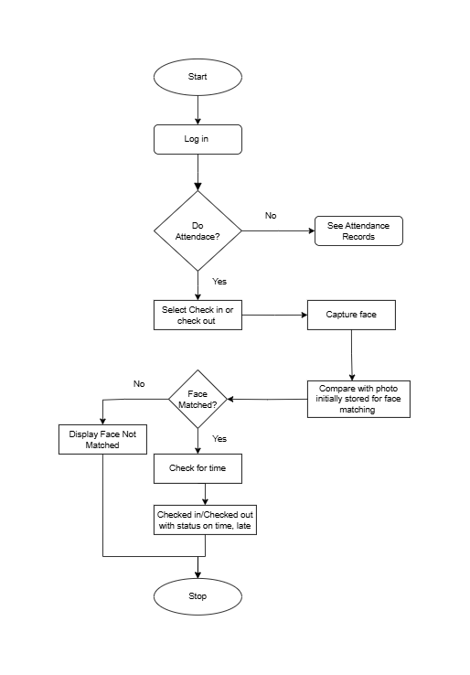

**Figure 1: Flowchart of User**

2.Admin

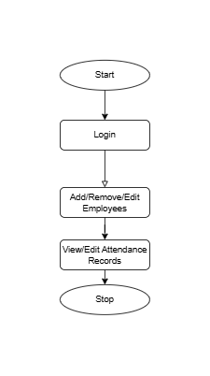

**Figure 2: Flowchart of Admin**

### 4.3.2 Methodology of proposed system

The commonly used methodologies include agile development methodology, waterfall method and rapid application development. There are few other methodologies depending upon the nature and objective of the software.

In developing entire system, I will be using the Waterfall Development Model. This is the most suitable model for our system. In addition, this model is very simple and easy to understand then others model. It is easy to manage and arrange tasks. Each phase must be completed before the new phases start, so there is no overlapping in the phases. The following illustration is a representation of different phases of the waterfall model:

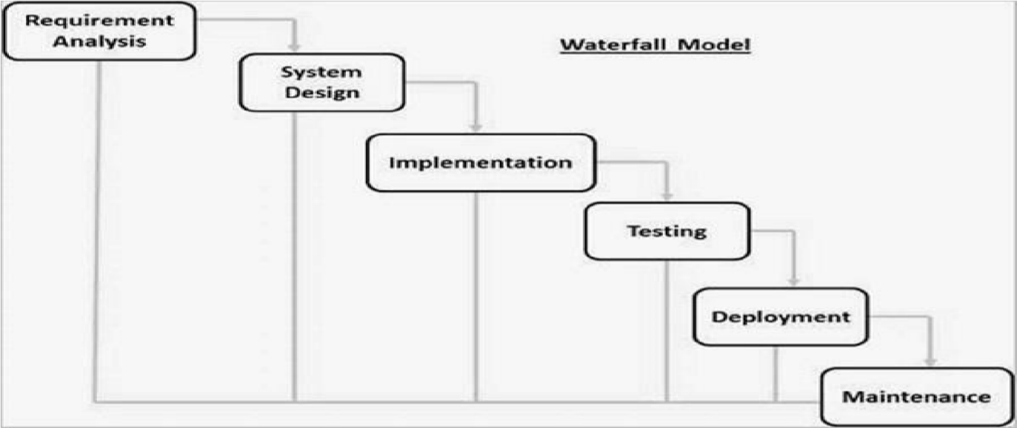

**Figure 3:Waterfall Model**

### 4.3.3 Working mechanism of proposed system

1. Face Detection (Capturing)

* A camera captures images or video frames of individuals.
* A face detection algorithm (e.g., MTCNN) identifies and locates faces in the frame.

2. Face Preprocessing

* The detected face is cropped and normalized (resized, converted to grayscale or RGB).
* Image enhancements (contrast adjustment, noise reduction) may be applied.
* The facial data is aligned to maintain consistency in recognition.

3. Feature Extraction

* Unique facial features (landmarks like eyes, nose, mouth, jawline) are extracted.
* A deep learning model (e.g., FaceNet, OpenCV DNN, or custom CNN) converts these features into numerical embeddings.

4. Face Recognition (Matching)

* The extracted face embedding is compared against stored embeddings in the database.
* A similarity score (e.g., cosine similarity or Euclidean distance) is calculated.
* If the similarity score meets the threshold, the face is recognized.

5. Attendance Marking

* If the face is recognized, the system marks attendance in the database.
* The system logs:
  + Name/ID of the recognized individual
  + Date and time of attendance
  + Additional details (location, device ID)

6. Data Storage & Management

* Attendance records are stored in MongoDB or any database.
* Logs can be retrieved and displayed in an admin panel.
* API endpoints allow integration with other attendance management systems

### 4.3.4 Description of Algorithm

**1. Face Detection**

**Algorithm Used**: **Multi-task Cascaded Convolutional Network (MTCNN)**

**Description:**

The **MTCNN algorithm** is a deep learning-based face detection method that detects faces and aligns them by identifying key facial landmarks (eyes, nose, and mouth). It works in three stages:

1. **Proposal Network (P-Net)** - Generates candidate face regions.
2. **Refinement Network (R-Net)** - Filters false positives.
3. **Output Network (O-Net)** - Detects facial landmarks for alignment.

This method ensures high accuracy in detecting faces, even under varying lighting conditions and angles.

**2. Face Preprocessing**

**Algorithm Used**: **Histogram Equalization**

**Description:**

Before recognition, detected faces undergo **histogram equalization**, an image processing technique that improves contrast by distributing pixel intensity values evenly. This enhances feature visibility, making face recognition more robust to lighting variations.

**3. Feature Extraction**

**Algorithm Used**: **Principal Component Analysis (PCA)**

**Description:**

**PCA** is a dimensionality reduction algorithm that extracts important facial features while removing redundant data. It converts face images into **eigenfaces**, reducing the number of variables while retaining essential facial characteristics. This helps in faster and more efficient face matching.

**4. Face Recognition (Matching)**

**Algorithm Used**: **Euclidean Distance with Face Embeddings**

**Description:**

The recognized face is converted into a numerical embedding (vector) and compared with stored embeddings using **Euclidean Distance**:

d(A,B)=i=1∑n​(Ai​−Bi​)^2

Where:

* A and B are face embeddings.
* If the distance is below a certain threshold, a match is confirmed.

This method ensures accurate face verification in a database of multiple individuals

# **Gantt Chart (Project Timeline)**

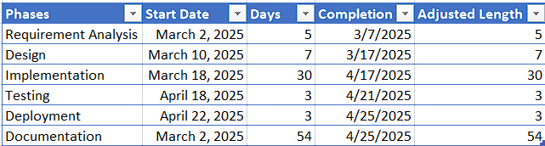

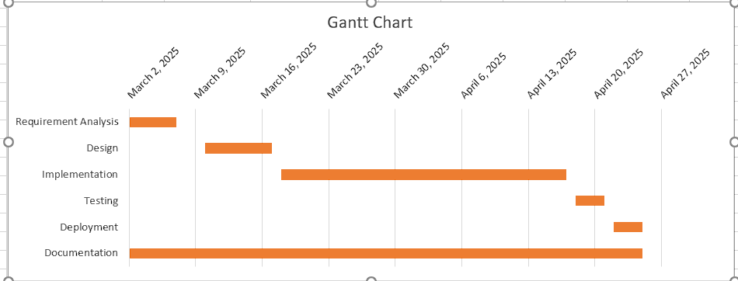

**Figure 4: Gantt Chart**

# **6. Expected Outcomes**

The Face Detection Attendance System is expected to automate the process of marking attendance efficiently and accurately. By utilizing facial recognition technology, the system will eliminate the need for manual attendance tracking, reducing errors and the possibility of proxy attendance. The system will successfully detect and recognize registered individuals, logging their attendance with a timestamp in real-time. This will provide a seamless experience for both employees or students and administrators managing attendance records.

# **7. References**

[1] “Advanced biometric time clock systems & visitor management solution,” NCheck by Neurotechnology, https://www.ncheck.net/

[2] Lystface, https://www.lystface.com/